Amir Mamdouh Helmy Shaker
Fawry Assessment
Task1

The first part in mygrep.sh Script
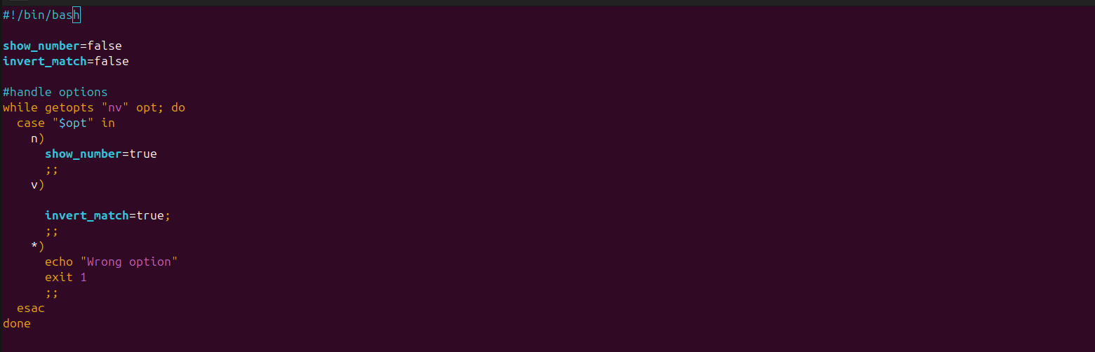
here I’m handling Options n and v
I check If the user enter option n or v or both.

Step 2
- Shift options to start focus on inputs
- start to validate inputs and check if there’s any exceptions
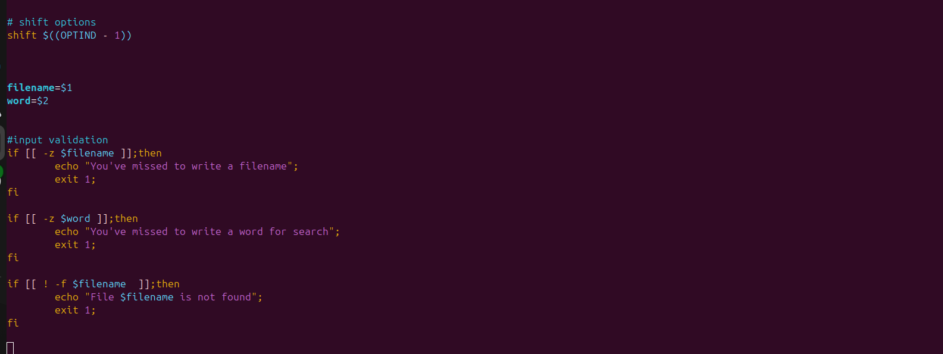
Step3
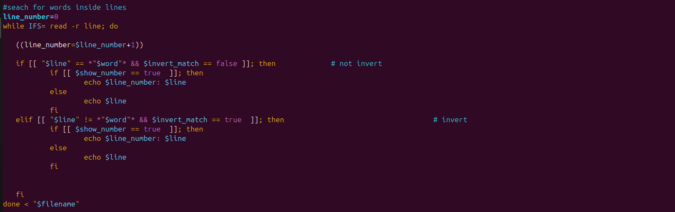
- IFS refers to getting each line as an item not splitting items by spaces.
- read lines of $filename
we interested to print line in two cases:
1- the word pattern exists and v option doesn’t exist
2- the word pattern doesn’t exist and v option exists

The most challenging part of the script was likely handling the combination of -n and -v options. This is because these options modify how the matching lines are displayed:
- The -n flag requires the script to output line numbers, which means the script needs to track the line numbers while reading the file.
The -v flag requires the script to invert printing lines, which means you have to print non-matching lines instead of matching ones.

